Assignment 1 - Docker 2

Case study:

1. Create and run container with Bind mount

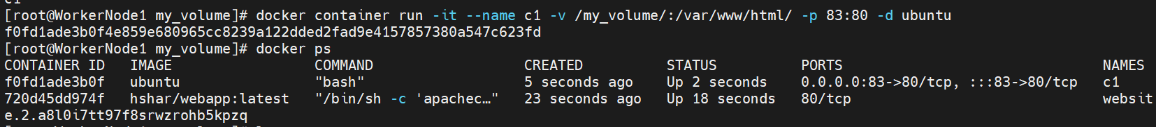

Sample html file

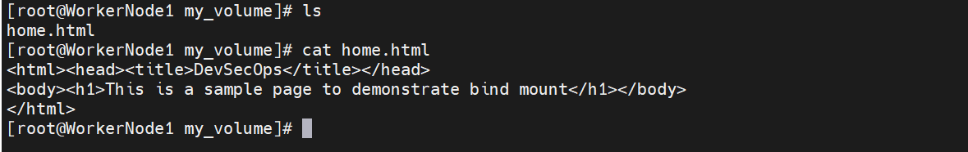

Install apache2 in the new ubuntu container



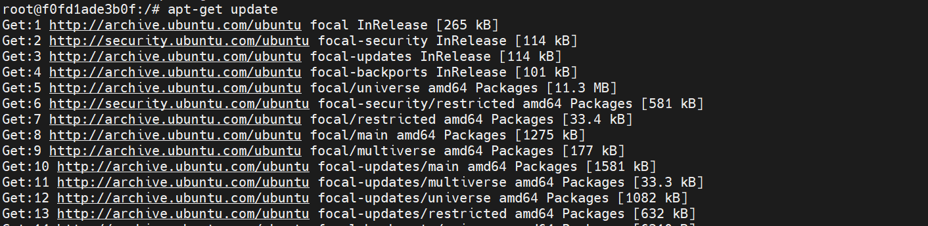

Start apache2 service and exit

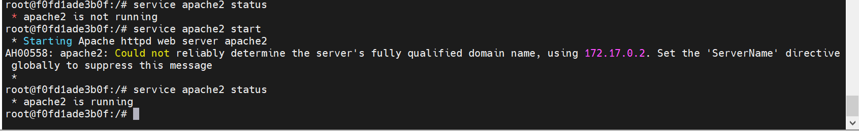

Test using curl cmd and webpage:

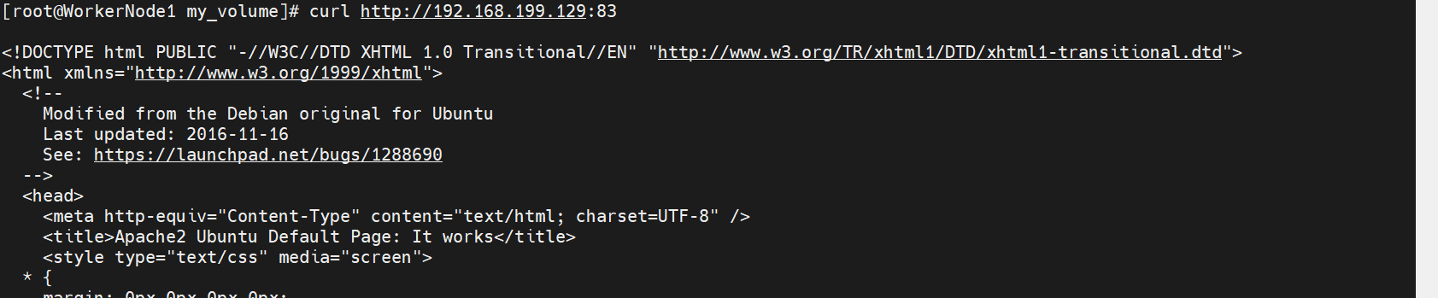

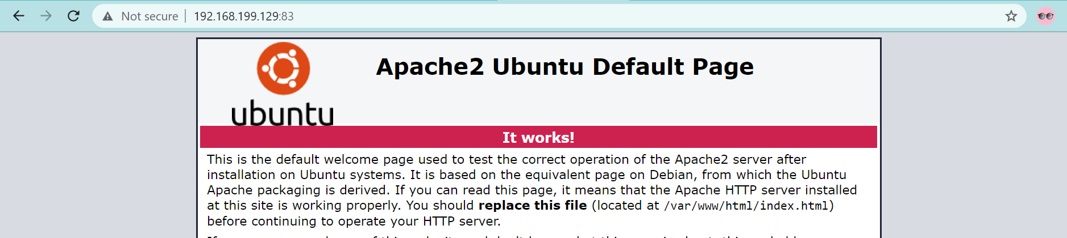

Home.html



Modify home.html in the host machine and test





1. Deploy apache & nginx using docker compose file

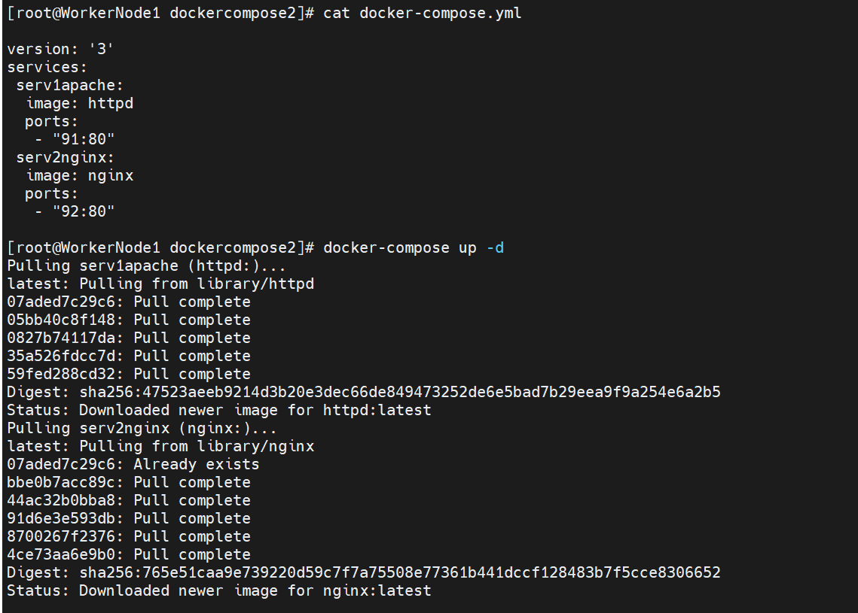

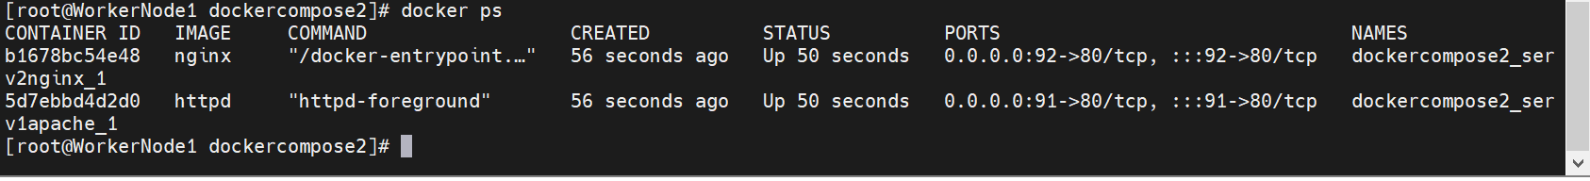

1. Docker swarm cluster

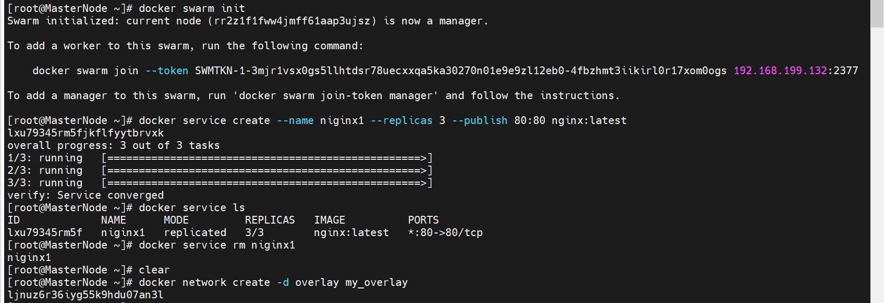





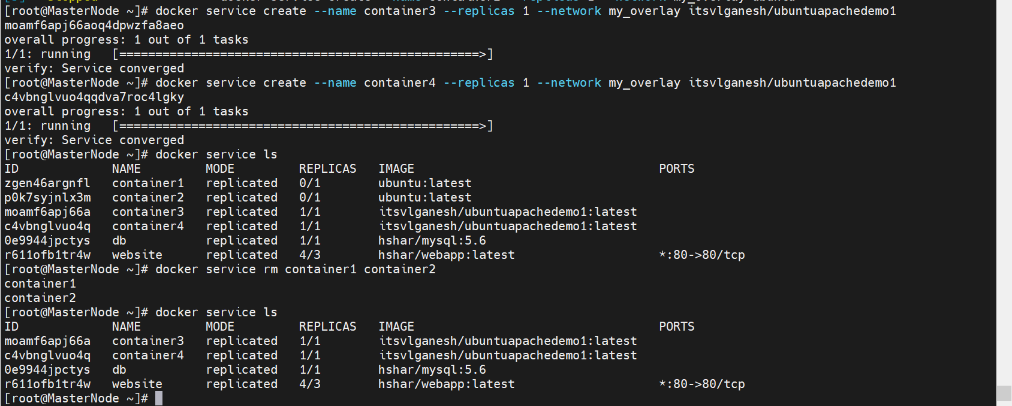

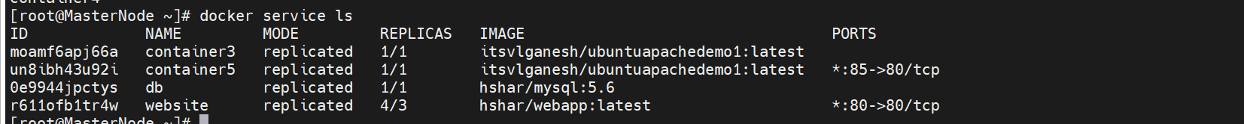

Get into Container5 and ping Container3







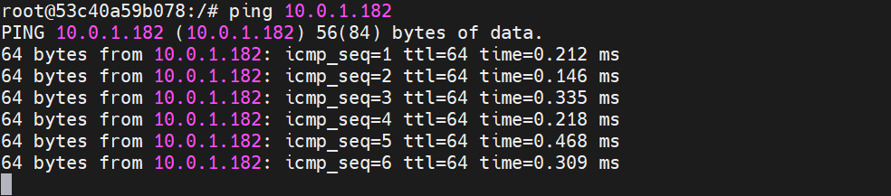

Assignment:

1. Use the bind mount container from case study and modify index.html in the host machine

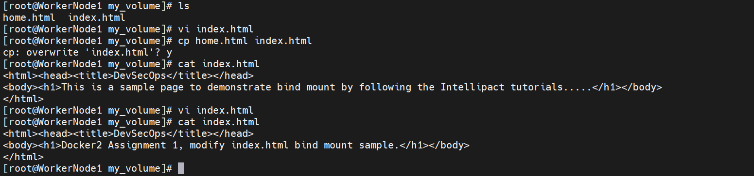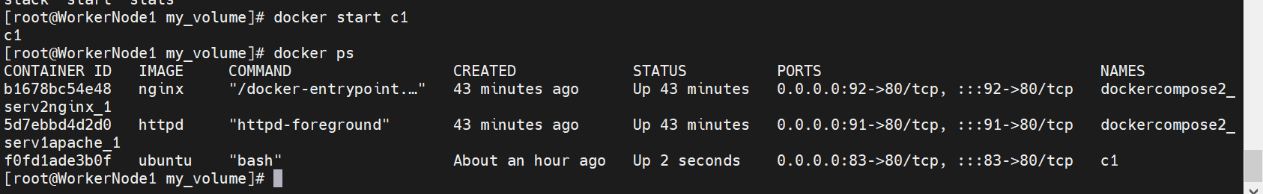

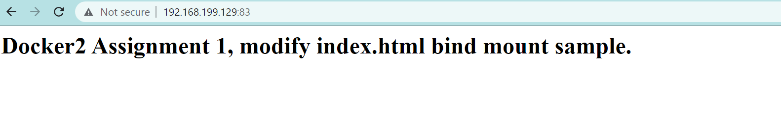

1. & 3. Docker swarm scale up and scale down replicas

